Review: Joshua 12 – Judges 5

Joshua 12
A general review of lands & kings conquered to the point where the land is given out by lot to the tribes.
Larger campaigns are completed – mopping up operations get underway

Joshua 13 – 19
Land distributed to 9 tribes + 1/2 of the half tribe of Manasseh

General Principles pertaining to Land-Grants
Blocks of land were assessed and boundaries established by geographic survey
Distribution given out by Lot. Thus the hand of God is involved
Distribution given in proportion to tribe size

Joshua 13:
The command to divide the land
A rehearsal of grants already in place on the east side of the Jordan – given to Reuben, Gad and Manasseh
Note: vs 33 – no block of land given to Levi. The Lord is his portion.
Joshua 14:
Caleb: Moses’ promise kept. Hebron awarded to Caleb’s family
Land awarded within Judah’s territory

Joshua 15:
Tribe of Judah: cities enumerated along with accompanying land
Jebusites remain unconquered – not accomplished until the time of king David

Joshua 16
Sons of Joseph
Tribe of Ephraim (vs 5-10)

Joshua 17
Tribe of Manasseh (vs 1-13)
Special provisions for the daughters of Zelophehad – precident setting.
(See also Number 27:1-11 and 36:5-9)

A special request for more land – vs 14-18
Answer: clear the forest, drive out the enemy
Joshua 18
Gathering at Shiloh –
to urge those with land-grants – to take the land
To put measures in place for dividing the remaining land between the seven remaining tribes
Survey taken of the remaining land
Lots cast for the Lord to indicate who gets what.
Benjamin’s land (vs. 11-28) – located within Judah’s territory
Joshua 19
Simeon’s land (vs 1-9)
Zebulun’s land (vs 10-16)
Issachar’s land (vs 17-23)
Asher’s land (vs 24-31)
Naphtali’s land (vs 32-39)
Dan’s land (vs 40-48)
Joshua’s grant (vs 49-50) As with Caleb, treated separately

Note: Eliezar the priest and Joshua along with elders from all the tribes provided oversight in this process to ensure fairness and equity
Joshua 20
Cities of Refuge
- West of Jordan: Kedesh in Galilee, Shechem in Ephraim, Hebron in Judah
- East of Jordan: Bezer in Reuben, Ramoth in Gilead (Gad) , Golan in Bashan (Manasseh)
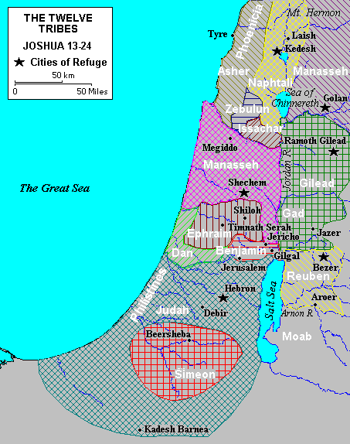
Joshua 21
Levitical Cities – named in vs 9-40

Division by lot:
- Kohathaties – 13 cities in Judah, Simeon & Benjamin
10 cities in Ephraim, Dan & Manasseh
- Gershonites – 13 cities in Issachar, Asher, Napthali and Mannaseh in Bashan
- Merarites - 12 cities in Reuben, Gad, Zebulun

Note: Vs. 44-45
God gave them rest on every side.
Not one of the good promises of the Lord failed

Joshua 22
The return of Reuben, Gad and Manasseh to the transjordan
- An altar for a memorial
- A formal inquest – due diligence on the part of Israel’s leaders

Joshua 23
Joshua’s first farewell speech
- Given to the leaders
- Probably still at Shiloh (18:1, 19:51, 21:1)
- Instruction, warning and exhortation

Joshua 24
Joshua’s final farewell speech
- At Shechem
- Given to all Israel
- History recounted for it’s theological significance
- Exhortation to faithfulness
- The covenant renewed under oath

Joshua and Eleazar’s deaths recorded
Burial of Joseph’s bones

Outline of Judges

I. Partial conquest of Canaan by Israel, 1:1–2:5
II. Reasons for survival of Canaanite remnants, 2:6–3:6
III. Oppression under Cushan-Rishathaim, deliverance by Othniel, 3:7–11
IV. Oppression under Eglon of Moab, deliverance by Ehud, 3:12–30
V. Exploits of Shamgar, 3:31
VI. Oppression under Jabin of Hazor, deliverance by Deborah and Barak, 4:1–24
VII. Song of Deborah, 5:1–31
VIII. Oppression under Midian, deliverance by Gideon, 6:1–8:35
IX. Career of the tyrant Abimelech, 9:1–57
X. Judgeships of Tola and Jair, 10:1–5
XI. Oppression under Ammonites, deliverance by Jephthah, 10:6–12:7
XII. Judgeships of Ibzan, Elon, and Abdon, 12:8–15
XIII. Oppression under Philistines, the exploits of Samson, 13:1–16:31
XIV. Micah’s priest and the Danite migration, 17:1–18:31
XV. Atrocity at Gibeah and the Benjamite war, 19:12–1:2

Note:
All the author’s material has been arranged according to a unitary plan exhibiting a single dominant idea: Israel’s welfare depends upon her spiritual relationship to Jehovah.

Characteristic formulas are used which introduce or bring to a close each stage in the narrative.

- A characteristic introduction is, “And the children of Israel did evil in the sight of the Lord” (cf. 3:7, 12; 4:1; 6:1; 10:6; 13:1).

- Often a section is closed by the comment “and the land had rest [a certain number of years]” as in 3:11, 30; 5:31; 8:28.

There is a cycle that keeps repeating itself
Apostasy, Afflication, Repentance, Deliverance

Moeller points out that the fourteen judges are so arranged that Othniel and Samson stand alone at the beginning and at the end of the series, but those who come in between are usually connected in pairs.

- Thus Shamgar (3:31) appears as a brief adjunct to Ehud (3:12–30);
- Barak is of course paired up with Deborah;
- There is a fairly clear connection between Gideon and his natural son, Abimelech.

THE JUDGES OF ISRAEL

Judge Enemy Oppr Years Years Deliv Date Reference

Othniel Mesopotamia 8 40 1374–1334 (3:9–11)

Ehud Moab Ammon
Midian 18 80 1316–1235 (3:15–30)

Shamgar Midian ca. 1230 (3:31)

Deborah Canaan 20 40 1216–1176 (4:4–5:31)

Barak Canaan 20 40 1216–1176 (4:4–5:31)

Gideon Midian 7 40 1169–1129 (6:11–8:35)

Tola Amalek 23 1120–1097 (10:1–2)

Jair Amalek 22 1120–1097 (10:3–5)

Jephthah Ammon 18 6 1085–1079 (11:1–12:7)

Ibzan Ammon 7 1079–1072 (12:8–10)

Elon Ammon 10 1072–1062 (12:11–12)

Abdon Ammon 8 1062–1054 (12:13–15)

Samson Philistia 40 20 1095–1075 (13:2–16:31)

Note:

it is best to think of the judges operating in different parts of the country – and some of them doing so at the same time. Thus, Samson and Jephthah are at work at the same time. Samson in Philistia (Judah) and Jephthah in Gilead.
- Judges were local leaders – not national ones.
- Their positions were not hereditary or passed on to their children
- God raised them up to meet the occasion

Review Judges: 1-5

Judges 1
Limited early success in taking the land – efforts peter out.
Overall failure to possess the land and drive out pagan nations.
Local leaders do not pick up the task where Joshua’s generation left off
Problem: idol worship, intermarriage and neglect to keep God’s commands

Judges 2
Angel of the Lord at Gilgal - condemnation of Israel
- Made covenants with pagans
- Intermarried with people of land
- Worshipped idols
- Therefore, God is turning against them – no longer give them successful

Introduction of Judges
- Their limited role is described

Judges 3
Cushan-Rishathaim: Mesopotamian king
Deliverer: Caleb’s younger brother Othniel

Eglon – king of Moab
Deliverer: Ehud

Philistines
Deliverer: Shamgar

Judges 4
Jabin – King of Hazor (Sisera his general)
Deliverers: Deborah and Barak
Sisera killed by Jael – wife of Lappidoth the Kenite

Judges 5
Song of Deborah – celebrating God’s defeat of Jabin & Sisera

